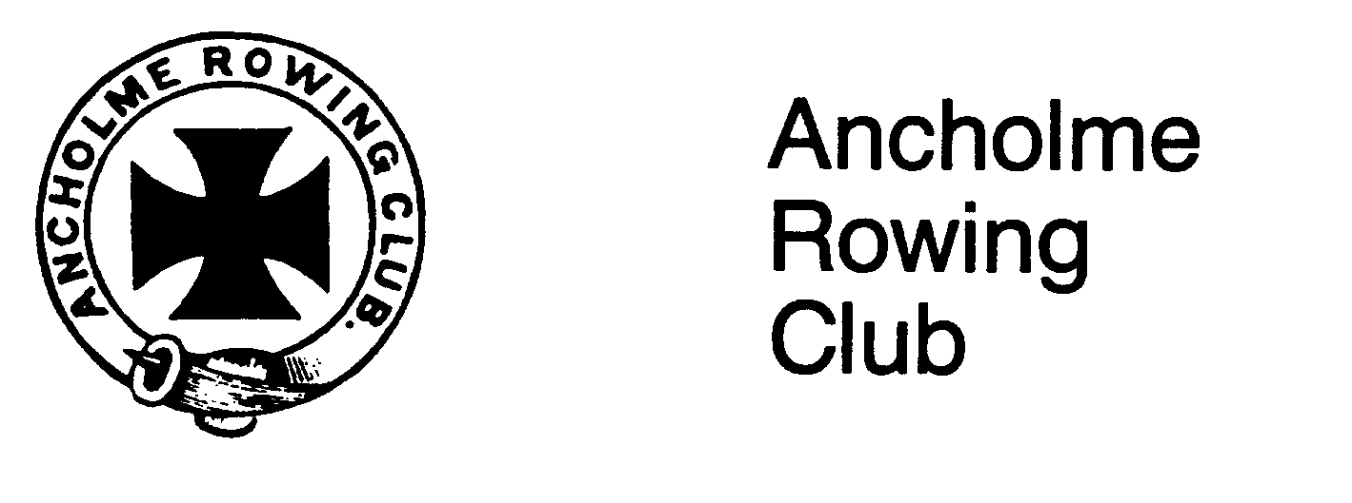
Thank you for entering the Ancholme Head. Please read the following instructions.

ANCHOLME HEAD – COMPETITORS INSTRUCTIONS

IF FOR ANY REASON YOU NEED TO MAKE ANY CHANGES TO YOUR ENTRY OR HAVE ANY QUERIES PLEASE CONTACT PENNY BARKER ON  07801 244638

1. There are two boating options: Ancholme Rowing Club, Manley Gardens, Brigg & the landing stage near the new road bridge in Brigg. You will be informed by email, prior to the event, which boating option your club is using.

2. At junction 4 on M180 follow signs to A18 then follow signs to Brigg. As you enter Brigg, trailer parking is in Bridge Street (NB: unless you have been informed you are boating from Tescos). Car parking is on the left at Peacock and Binnington. Somebody from ARC will be around to direct you. NB: DO NOT BLOCK BRIDGE STREET. ACCESS IS REQUIRED DOWN THIS ROAD AT ALL TIMES.

FOR THOSE BOATING FROM TESCOS - DO NOT PARK IN THE RIVERSIDE SURGERY CARPARK – THE SURGERY IS OPEN ON SUNDAYS

3. All crews should book in by 09.30 (registration is upstairs in the club house). Please note that boating times of crews in the lower half of Division 1 will be from 09.30.

4. Racing will start at 11.00 and 14.30. Crews arriving late at the start may be penalised.

5. All crews are allocated a boating time on the back of their numbers. Please make every effort to keep to these.

6. Each sculler and bow person must wear the number allocated during the race and the plastic number provided must be on the boat’s bows. Provisional start order is displayed on the Boat House Door.

7. Crews should TURN & marshal above the start in number order with the highest number crew furthest from the start. There are markers with letters A to E along the bank, please see the back of your number for the exact location where you should wait. The start marshalls will inform you of which side of the river to wait on.

8. Crews will start at 15 second intervals and will be called to the start, PLEASE STOP AT MARKER A, you will be told when to set off to the start. Crews will then be timed from the south side of Broughton Bridge to the north side of the Motorway Bridge.

9. Trophies won may be retained for one year. Tankards or other prizes will be awarded to the winning crew members.

10. British Rowing Rules of Racing apply.

11. Keep your bowside to the bank to allow crews to overtake on your strokeside.

12. In the event of any objections the decision of the Race Committee will be final.

13. Changing facilities, toilets, refreshments etc. are available at the rowing club.

14. Please see the safety plan for event safety information. You are responsible for ensuring each competing person that you have entered from your club has read the enclosed plan. The most important part of the safety plan from a competitor’s view point is - IF ASKED TO STOP BY A RACE OFFICIAL YOU MUST STOP – SOMEONE’S LIFE MAY BE AT RISK.

We hope you enjoy Ancholme Head.
